Paradox of Mitigating the Achievement Gap: Digital Technology and Socioeconomic Inequality in PISA 2025
Yue Jiang
2026

Abstract
Digital technology has expanded access to educational resources. In this paper, we investigated the moderating effect of 12 ICT indicators across 5 categories (access, frequency, use, interest, AI usage) on the relationship between students’ socioeconomic status (SES) and academic achievement, using a cleaned PISA 2025 dataset of 335,424 observations across 44 countries. The baseline, additive, and interaction models were estimated using weights and controlling for country and gender. We found that a one-unit increase in SES is associated with a 30- to 32-point increase in students’ science scores. Varying moderating effects were shown from different ICT indicators: 4 negative interactions, 3 positive interactions, and 5 nonsignificant interactions. It further highlighted the importance of analyzing the multidimensional nature of ICT. A key finding of this research is that all 4 indicators with negative interactions show a negative association with science scores controlling for SES, country, and gender. This means the achievement gap is narrowing across different SES groups as ICT increases, but in a way that an ICT increase for high-SES students is associated with a larger science score decrease compared to low-SES students. However, interaction terms added relatively little explanatory power, and this study cannot conclude causation because of the survey nature of PISA. This paper also provides initial insight into large-scale data on AI use in education. We have found AI use for school work negatively associates with science scores and has a negative interaction term.

Introduction
Technology today has transformed many aspects of our lives, including education. Its rapid improvement is outpacing the policies and implementation of it. The real effect of digital tools is not yet well understood. Some say they make access to resources easier; others say that it might distract students from studying.

This is further complicated by the relationship between socioeconomic status and academic achievement. Privileged students often correlate with higher academic achievement scores. The achievement gap has been extensively researched since the 20th century. Debates center on how educational infrastructure, policies, parental guidance, and cultural resources shape students’ academic achievement. Digital technology’s involvement in this relationship has yielded conflicting findings. Does technology reduce existing inequalities or reinforce them?

AI is being adopted at an unprecedented speed, including in education. Large-scale data on AI use and evidence of its impacts remain limited. This study introduces a new AI measure implemented in PISA 2025 as a preliminary indicator of AI’s potential in education.

To address these gaps, we pose two research questions:

RQ1. To what extent does students’ use of digital technologies moderate the association between socioeconomic status and academic achievement in PISA 2025?

RQ2. Can AI potentially mitigate academic achievement gaps across different socioeconomic groups?

Literature Review

Effect of SES on achievement
SES (socioeconomic status) is a person’s social and economic position in society, measured by their income, education, and occupation (American Psychological Association, 2026). The positive relationship between SES and academic achievement has been extensively documented for decades.

SES is measured in many different ways across international assessments. The Organisation for Economic Co-operation and Development (OECD) uses ESCS (Index of Economic, Social and Cultural Status) to measure socioeconomic status. According to the OECD, ESCS has three key components derived from student questionnaires: parental education, parental occupation, and home possessions (OECD, 2026). It is computed so that all students globally can be compared on one scale.

Overall, there is a significant positive relationship between ESCS and achievement in the past PISA cycles (Scherer & Siddiq, 2019; Vargas-Montoya et al., 2023). A meta-analysis by Scherer and Siddiq found an overall positive and significant trend in 11 studies (Scherer & Siddiq, 2019). Others, like Strenze (2007), found weaker positive relationships between SES and academic achievement. Previous research documented compelling theories to explain this relationship.

Social Reproduction Perspective
Social reproduction is the idea that benefits from parents facilitate students' success in academics (Guerra et al., 2026). It encompasses a wide variety of resources such as schooling, social networks, cultural familiarity, material resources, etc. These resources provide students with implicit opportunities to learn that are not available to other families. These cross-generational resources translate into the advantages students receive in academic performance. For example, students from high-SES backgrounds have better access to the internet, more books at home, and greater investment in their education. Parental education has always been a strong indicator of SES. From an analysis of the PISA 2018 cycle, one additional year of parental education correlates to an advantage of 3.258 points in Mathematics and 3.000 points in Reading (Loh et al., 2023). Parents with high levels of education often place a high value on their children’s education. They guide students in their academic choices and provide support in their education.

School/country-level factors
Other school-level and country-level factors have also been shown to contribute to the relationship between SES and academic achievement. Esen & Adigüzel (2023) found that ESCS is a better predictor in private schools than in public schools. One possible explanation is that, there is more disparity in educational investment and support from parents whose children attend private schools, while public schools are relatively more uniform. Therefore, there might be a greater margin of benefit for private school students.

In summary, prior research established a positive association between national wealth and student performance (Kastorff et al., 2025). Previous findings also suggest that country-level indicators such as HDI (Human Development Index) can have a significant moderating effect on the relationship between SES and digital competencies (Kastorff et al., 2025). This is likely due to countries having different educational infrastructure, investments, and policies. Park and Weng found an interesting negative impact of national income inequality using the Gini index and academic achievement (Park & Weng, 2020). Some factors could be higher income segregation and higher poverty in countries with income inequality. Park and Weng assert that promoting policies that address income inequality can potentially mitigate the divide. Given there are wide differences between countries, we will control for country-level differences in the analysis.

Overall, the positive relationship between SES and academic achievement is a combined effect of many factors.

Effect of ICT on achievement
Information and Communication Technology (ICT) is an umbrella term that encompasses the general use of digital tools and the communication of information online. It has emerged as an important predictor of student achievement (Esen & Adigüzel, 2023). While many studies focused on one or two components of ICT (Loh et al., 2023), this paper aims to cover the multidimensional aspects. We have found that there is no single answer to the relationship between ICT and student achievement. Rather, there are mixed effects across different ICT measures.

ICT Access
Recent analyses found that ICT access alone no longer predicts student achievement. Access is measured by the frequency of use in the PISA assessment, which does not guarantee the quality of ICT use for learning. Some studies found a negative relationship between ICT academic use at home/school and student achievement (Park & Weng, 2020). Vargas-Montoya et al. (2023) argue that as ICT becomes increasingly widespread, significant ICT measures will shift toward the quality of access, ICT skills/literacy, etc.

ICT Use
For ICT use, we will talk about two uses in the PISA assessment. ICTINFO captures information-seeking activities and verifying information. Previous literature generally found a positive association between ICTINFO and student achievement (Loh et al., 2023; Vargas-Montoya et al., 2023). It is not surprising to find this positive relationship, because seeking information online often requires critical thinking and evaluation, which are important skills to succeed academically. It is also an apparent way to learn information digitally.

Academic use of ICT at home/school shows a mixed relationship with academic achievement.
Spiezia (2010) found that the positive correlation between ICT and achievement is heavily driven by ICT at home, and ICT at school has little effect on achievement. They argue that ICT in the classroom has not yet been fully integrated with traditional teaching strategies. Schools lacking policies and software might not effectively assist students. On the other hand, ICT at home generates interest and autonomy in students. Students can search for tools that tailor to their learning needs (Spiezia, 2010). This calls into question the vast investments in school technology infrastructures globally. However, Park & Weng (2020) found negative relationships between both ICT at home and school and academic achievement. Possible explanations could be similar to ICT access, where we cannot guarantee the quality of ICT use in these cases. It is also likely that students get distracted by devices while studying. Previous research has not reached an agreement on the impact various ICT uses have on academics.

ICT Competency, Interest, and Skills
Back before 2019, most, if not all, studies focused only on access and usage (Scherer & Siddiq, 2019). But in recent years, ICT competency, interest, and skills are slowly gaining recognition. Many recent studies show these aspects have significantly greater effects than mere access (Fayda-Kinik & Cetin, 2024; Ghimire & Regmi, 2025; Kastorff et al., 2025; Loh et al., 2023). This pertains to the earlier principle of quantity vs. quality. Surprisingly, Loh et al. (2023) found that the effect of ICT skills boost is comparable to the advantage gained from higher parental education.

There are many explanations for this gap between access and other aspects of ICT (competency, interest, skills, etc.). Students might not realize the expected benefit that ICT can bring. They might also lack knowledge of how to use it effectively. For example, a student given devices can misuse them for gaming, chatting, and socializing, which can displace their study time and therefore have no or a negative effect on academics. Another example is a student actively seeking information for their homework, yet he is not equipped with how to do so on these tools and could be misled by the wrong source of information. ICT competency, interest, and skills can prepare students for better academic autonomy, independent research, evaluating information, and avoiding ICT distraction. Because of this, many researchers call for more investment in helping students learn to use these tools effectively. This can be through schools’ curricula or parental guidance.

Combining previous literature, we found that there are many different aspects of ICT with varying effects on academic achievement. Because of this, it is important to analyze the multidimensional aspects of ICT in future analyses.

SES inequality in digital access and use
To inspect ICT’s role in the relationship between SES and academic achievement, it is important to understand the digital divide. The digital divide is an economic and social inequality regarding access to, use of, or impact of information and communication technologies (Brown, 2020). The digital divide is separated into three levels:

The first level of the digital divide difference in the physical access to digital technologies such as devices and internet connectivity. In the context of education, this is the disparity between students who do not have ICT at home or at school and students who have access. This is likely the largest impact of student SES. Families of low-SES are less likely to be able to afford ICT for their children compared to high-SES families. However, many experts today propose that this first level is closing as ICT becomes more ubiquitous (Loh et al., 2023). OECD (2015) reports that the first digital divide shrank between 2009 and 2012 due to decreased cost and higher parental value of technology (Chiao & Chiu, 2018). Researchers have shifted focus towards the second digital divide.

The second digital divide consists of individuals who have access to ICT but have varying digital competencies. SES is still a key driver of this disparity, as students from high SES backgrounds often outperform students from low SES backgrounds (Kastorff et al., 2025). Further explanations of this will be in the ICT moderation section.

The third digital divide is a relatively new concept cited only in a few sources. It refers to the disparity in the benefits gained from ICT. Some examples of benefits could be careers and higher salaries. In the context of academics, it is the advantage students gain in their academic achievements from using ICT. This is also the key measure this study tries to gain insight on.

Some research shows that Covid 19 exacerbated the digital divide, even the first-level divide of basic access (Gabriel, 2024; Kastorff et al., 2025). During the pandemic, the shift to online learning made education increasingly dependent on digital resources and families’ socioeconomic circumstances. The abrupt shift immediately cut learning participation for some low-SES students who lack resources and directly affected students’ academic achievements. This result of a natural experiment brought awareness to an urgent need for systematic change in ICT and education.

Through exploring the digital divide, we found that ICT and SES have an interrelationship affecting students' academic achievement. Could technology remedy the gap in academic achievement between students with privileged backgrounds and less privileged backgrounds?

ICT Moderation

The research on ICT moderation in the SES-achievement relationship is still at a nascent stage. Currently, there are two competing theories:

ICT as a compensatory resource
Loh et al. (2023) proposed a social mobility perspective where the benefits of ICT resources act in a compensatory role for low-SES students. Some students might not have access to private tutoring or physical books. ICT provides resources such as information, skills, and other academic gains that weren’t available to those from less privileged backgrounds. These resources might act as a compensatory resource for social mobility. Low-SES students might benefit more from these ICT resources than high-SES students would because low-SES students gain more things that weren’t available, while high-SES students gain little in addition to many resources they already have. In other words, ICT will have a larger marginal effect on low-SES students. However, other factors such as student autonomy and interest contribute to the result as well.

There is research that supports this optimistic theory. Ghimire & Regmi (2025) found that home ICT access had dramatically larger benefits in technology-poor schools; Gonzalez-Betancor et al. (2021) suggested that ICT integration at schools compensates for digital inequalities at home for students in 21 European countries. Interestingly, Loh et al. (2023) showed a negative compensatory pattern for recreational gaming. Recreational gaming negatively correlated with academic achievement, and high-SES students were impacted more by gaming compared to low-SES students, which narrows the achievement gap.

ICT as an accumulation of advantage
The Matthew effect says that those who possess resources accumulate more, while those with few resources fall behind (Campbell, 2023). In terms of educational context and technology, high-SES students benefit more from ICT resources than low-SES students, amplifying the preexisting achievement gap between low- and high-SES students.

A widely accepted explanation of this is the difference in digital literacy. Digital literacy is the skills, practice, and knowledge to use digital resources effectively. Differences in digital literacy can result in unequal benefits of ICT, which is addressed in the third digital divide. High-SES students are more likely to be in an environment where ICT is frequently practiced, at home or at school. Scherer & Siddiq (2019) and Kastorff et al. (2025) both found a positive correlation between socioeconomic status and ICT literacy. Kastorff et al. (2025) indicated that country-level (Digital Readiness Index, Human Development Index) and school-level moderators (availability and use of digital tools) weakened the relationship between SES and digital literacy, meaning that SES is not the sole factor in digital literacy.

Students from privileged backgrounds have implicit learning opportunities that are provided in their environment. For example, parents of these students likely work in sectors where digital resources are more prevalent, exposing students to these resources. These parents are also more likely to value digital resources and oversee their children's ICT usage. Students will learn to use ICT effectively in their studies. On the other hand, students from less privileged backgrounds are less exposed to digital resources. When they do have access, they might not have knowledge or guidance on how to use them properly. School ICT infrastructure might amplify this gap as well: schools with larger investments could invest in more digital pedagogical tools and assist students in developing digital skills.

Overall, the current literature leans slightly toward ICT as an accumulation of advantage over ICT as a compensatory resource. A study of East Asian students using PISA 2012 found that students from high-SES families get more benefits from ICT usage, while avoiding the negative impacts (Chiao & Chiu, 2018). Loh et al. (2023) found that a high-SES student who is highly ICT-skilled would gain 39.6 points in math from an increase in ICT skills compared to 5.6 points for a low-SES student. In a country-level analysis, Vargas-Montoya et al. (2023) found that the relationship between ICT usage in class and PISA scores favors students from high-income countries more than middle-income countries.

AI in Education
The PISA 2025 cycle is the first time AI is introduced. According to OECD (2026c), generative AI chatbots only became publicly widespread in late 2022. Because of its recent emergence, its implications and effects are barely understood. OECD’s 2026c analysis found that although higher socioeconomic background is correlated with more access and more frequent use of AI tools, it does not explain the difference in academic performance among students.

AI use in education is often documented with both benefits and drawbacks. Some of the potential benefits of generative AI are providing immediate explanations/feedback, solving problems, inspiring new ideas, generating review quizzes for students, etc. It can support teachers as well if used properly, such as writing lesson plans and monitoring student progress. Some downsides of it include concerns about using AI as “crutches” (Khan, 2024). Students become overreliant on technology, and it displaces students’ critical thinking. AI can easily write essays and do homework without any effort from the students.

There are some initiatives to address this issue. Khan Academy cooperated with ChatGPT to develop Khanmigo, an AI education interface. It makes effective use of AI in ways such as answering in a Socratic style, debating with students, and being a counselor or a coach. Instead of providing direct answers to questions, it guides students to the right answers (Khan, 2024). Bastani et al. (2025) performed an experiment involving nearly 1,000 high school students in Turkey and assessed the difference in performance using GPT Base (unconstrained ChatGPT interface), GPT Tutor (coded interface similar to Khanmigo), and traditional materials (textbooks and course notes). The assessment is divided into two sessions: assisted sessions (assisted by assigned tools) and unassisted sessions. During assisted sessions, the GPT Base group and GPT Tutor group performed 48% and 127% better than the control group, respectively. During unassisted sessions, the GPT Base group performed 17% worse than the control group, while the GPT Tutor group showed no significant disparity compared to the control group. This shows that careful adjustment to the AI algorithm is capable of reducing its harmful effects.

Besides the socioeconomic status aforementioned, there are other factors that correlate with AI accessibility. Country-level policies, infrastructure, and resources often impact students’ use of technology. For example, Korea and Singapore implemented policies to foster digital learning, while Japan and Estonia, with less frequency of use in schoolwork, have limited policies regarding digital learning (OECD, 2026c). China and the United Arab Emirates have mandated education systems to implement AI education starting in 2025 (Sajadieh et al., 2026). School-specific factors such as location (rural/urban) and policies also have an impact on students’ access to AI and its effectiveness. According to Sajadieh et al. (2026), the percentage of public high schools offering CS courses in rural and urban areas (57% and 59%, respectively) is lower than in suburban areas (71%). They also noted that AI policies have not kept pace with the adoption of AI. Only half of middle and high schools in the US have AI policies.

Through the lens of education equity, we will elaborate on two competing theories of possible effects of AI.

AI as a compensatory resource
Generative AI can give personal feedback to students. These digital tools can tailor learning according to the student’s learning pace, skill level, and content they have struggled with. It acts as a private tutor, giving high-quality learning resources that were only available to students with privileged backgrounds historically (Mimoudi, 2025). Gabriel (2024) points out that this asynchronous interaction allows students with family duties or work or needing extra time to process studies to self-pace learning, enhancing their understanding and providing opportunities that were out of reach in traditional classrooms. AI’s support to teachers can contribute to mitigating the achievement gap as well. Mimoudi (2025) says AI can aid teachers to develop lesson plans and teaching strategies. It can also replace time used for routine progress monitoring and administrative tasks with higher-order teaching that benefits students even more. Efficient teaching is key to addressing teacher shortages. AI can also act as an exchange platform for Open Educational Resources for budget-constrained schools to provide students with quality and free learning (Gabriel, 2024).

AI can provide instant translation of materials to almost any language. In the English-dominant world, resources can be democratized for immigrant or non-native language learners. Additionally, AI tools can also easily convert text materials into speech or vice versa. Students who have visual or hearing impairments could benefit from these capabilities. For people with learning disabilities, AI can adapt study materials into simplified language or generate visual graphs/diagrams to aid understanding (Gabriel, 2024).

AI as an accumulation of advantage
This theory has gained prominence in recent research. Large Language Models are trained on massive amounts of data, much of which is from English-speaking and high-income regions (Matjie et al., 2026). Bias in algorithms related to race, culture, backgrounds, and gender becomes inevitable if unaddressed. Gabriel (2024) conducted an experiment where models are asked to grade the same paper but given different student backgrounds such as race, class, or type of school. The model gave biased evaluations of the paper. In the context of student socioeconomic status, students with lower SES backgrounds could be underrepresented in the training data. Cultural and language differences also need to be taken into account (Matjie et al., 2026).

Similar to ICT skills and literacy, knowing the effective use of AI can also impact the existing divide. Schools with less digital infrastructure may not be as prepared for student AI use, and students can misuse technology. Mimoudi (2025) shows that students with lower SES have less knowledge of data rights when using AI. This might be because schools and families are unaware of these risks. OECD (2026c) also reports that low SES students are less likely to be tasked with assessing the quality of information they get from AI.

Lastly, disparities between premium AI models and free models might also introduce gaps. High SES students are more likely to afford premium models, which give accurate and beneficial responses, while low SES students are likely to rely on free models that might give lower-quality responses (Gabriel, 2024).

The Current Study
The current literature is dominated by two-variable relationships such as ICT and student achievement or socioeconomic status and student achievement, and relatively few studies have explored interaction analyses using large-scale assessment data of SES and different ICT usage to predict scores. The interrelationships between these variables remain unclear. Loh et al. (2023) has developed similar interaction models on PISA 2018 data, but they have excluded countries that are not members of the Organisation for Economic Co-operation and Development (OECD). Its measure of socioeconomic status is also limited to parental education.
PISA 2025 introduced measures of students’ AI use for schoolwork, allowing extended analysis of this new emerging technology. This study will explore AI by implementing it as an ICT category.
Given the mixed findings in the existing literature, this study addresses the following research questions:

RQ1. To what extent does students’ use of digital technologies moderate the association between socioeconomic status and academic achievement in PISA 2025?

To explore the use of AI in education, the secondary research question asks:

RQ2. Can AI potentially mitigate academic achievement gaps across different socioeconomic groups?

Data
This study uses the Programme for International Student Assessment (PISA) 2025 cycle student data. Every three years, PISA collects and assesses the skills and knowledge of 15-year-olds across wide demographics. PISA 2025 cycle recorded assessments of over 750,000 students, representing about 33 million 15-year-olds in 91 countries.

Specifically, PISA assesses core subjects of reading, math, and science. Each round of PISA alternates one core domain subject, which is tested in more detail. PISA 2025’s core domain is science, as it was in 2006 and 2015.

Each student took a two-hour assessment containing multiple-choice and response questions; these items combine different subjects. Then, the students are asked to answer a 35-minute questionnaire on information about themselves. Some examples include where they are from, their home environment, characteristics, and family background. The Information and Communications Technology (ICT) familiarity questionnaire is an additional section that is only administered to certain countries. It focuses on the student’s ability, access, and attitude toward ICT.

The sampling of PISA is done in a two-stage stratified sampling design, which is a nested structure through countries and schools. A random sample of at least 150 schools is drawn for each participating country to represent their national population of 15-year-old students. Then, 42 students are randomly chosen in each school to take the assessment. Each student is given a final weight to adjust for representing an unequal population.

The sample used in this current study excluded countries that didn’t deliver the ICT questionnaire, which is 48% of all students. Samples with missing values in gender, country, socio-economic status, and weights were also removed. The final sample contains 335,424 students in 44 countries from the original 755,721 total observations.

Measures

ICT
According to OECD (2026b), ICT variables are constructed using Weighted Likelihood Estimation (WLE) from raw survey items. The raw survey items include questions such as “This school year, how often did you do the following tasks using <digital resources> in your school lessons? - Search for and find relevant information online”, “How often do you use Artificial Intelligence chatbots (e.g., <ChatGPT>) for your school work to do the following activities? - To help me learn”, and “To what extent do you agree or disagree with the following statements? - I am interested in learning more about <digital resources>.” Respondents select one option from a scale. Some examples of availability are “Never or hardly ever”, “Once or twice a week”, etc., and agreement questions use a five-point scale: 1 = strongly disagree, 2 = disagree, etc. Related questions are combined to generate ICT variables that are standardized relative to all samples. The specific ICT variables used in this study cover five general criteria: access, frequency, use, interest, and AI usage, as shown in Table 1.

The specific variables and labels are presented below:

Table 1. *
Access | ICTRES | ICT resources (WLE)
Access | ICTSCH | ICT availability at school (WLE)
Access | ICTHOME | ICT availability outside school (WLE)
Access | ICTQUAL | Quality of access to ICT (WLE)
Frequency | ICTWKDY | Frequency of ICT activity – Weekday (WLE)
Frequency | ICTWKEND | Frequency of ICT activity – Weekend (WLE)
Use | ICTFEED | Support or feedback via ICT (WLE)
Use | ICTOUT | Use of ICT for school activities outside of the classroom (WLE)
Use | ICTINFO | Students’ practices regarding online information (WLE)
Interest | DIGINTLRN | Interest in learning about digital resources (WLE)
Interest | INTICT | Interest in ICT (WLE)
AI Usage | AIUSESCH | Students' AI use at school (WLE)
* extracted from PISA 2025 Codebook

Socio-Economic Status
PISA’s socio-economic status is measured by the economic, social and cultural status (ESCS). ESCS has changed throughout the years to provide a usable and accurate measurement. For the past 4 PISA cycles (including 2025), ESCS is derived from three components related to family background: parents’ highest level of education, parents’ highest occupational status, and home possessions. ESCS is often considered an international standard of socio-economic status in large-scale assessments (Chiao & Chiu, 2018).

Academic Achievement
In the 2025 PISA cycle, science is the major domain, meaning it is assessed in more detail than reading and math. This study uses the science score to measure academic achievement. PISA states that it is not testing memorization but how knowledge can be applied to new situations (OECD, 2026b). It tests students’ competencies to explain science phenomena, construct and evaluate science investigations, and research science information for decision-making and action. In the first few PISA assessments, scores were standardized at 500 with a deviation of 100. Recent PISA cycles are calibrated for trend comparison; therefore, the science scores of the 2025 cycle might vary slightly from standardized scores.

Methodology
This study contains 12 ICT indicators that capture different dimensions of ICT. Because all ICT indicators contain missing values, indicator-specific samples are created. For each sample, any missing values on the selected ICT indicator are excluded (no missing values in the science scores, ESCS, and control variables because they were already excluded in data cleaning).

The control variables in this study are gender and country. Previous research shows a significant disparity between males and females, and many studies controlled for gender (Courtney et al., 2022; Vargas-Montoya et al., 2023). This study controls for countries because country-level factors might impact students’ ESCS, ICT use, and academic achievements, such as digital infrastructure/readiness and educational funding. Bulut & Cutumisu (2018) found that ICT at home and school was positively associated with achievement in Turkey, but not in Finland.

For each sample, the baseline, additive, and interaction models are run to allow for same-sample comparison. Figure 1 shows a diagram of the methodology used.

The baseline model examines the association between ESCS and science achievement:

$Y_{i}$ = $β_{0}$ + ${ β}_{1}$$ESCSᵢ$ + controls + εᵢ

The additive model introduces the selected ICT indicator:

$Y_{i}$ = $β_{0}$ + ${ β}_{1}ESCSᵢ$ + $β_{2}$$ICT_{i}$ + controls + εᵢ

The interaction model adds an interaction term of ESCS and the selected ICT indicator:

$Y_{i}$ = $β_{0}$ + ${ β}_{1}ESCSᵢ$ + $β_{2}$$ICT_{i}$ + $β_{3}$($ESCSᵢ$×$ICT_{i}$) + controls + εᵢ

For each student assessed, PISA reports 10 plausible values for each subject, instead of reporting the single test score directly. This is designed to adjust for unexpected circumstances in large-scale assessments. As recommended in OECD (2009), each model was estimated once for each of the ten plausible values, and averaged coefficients are reported.

PISA assessments contain weights for each student according to the population they represent. Weights are applied to all models in this study. All regression analyses were conducted using the intsvy package’s pisa.reg.pv() function, and both the final student weight (W_FSTUWT) and replicate weights for sampling variance (W_FSTURWT1–W_FSTURWT80) were automatically implemented.

Figure 1. Diagram of methodology
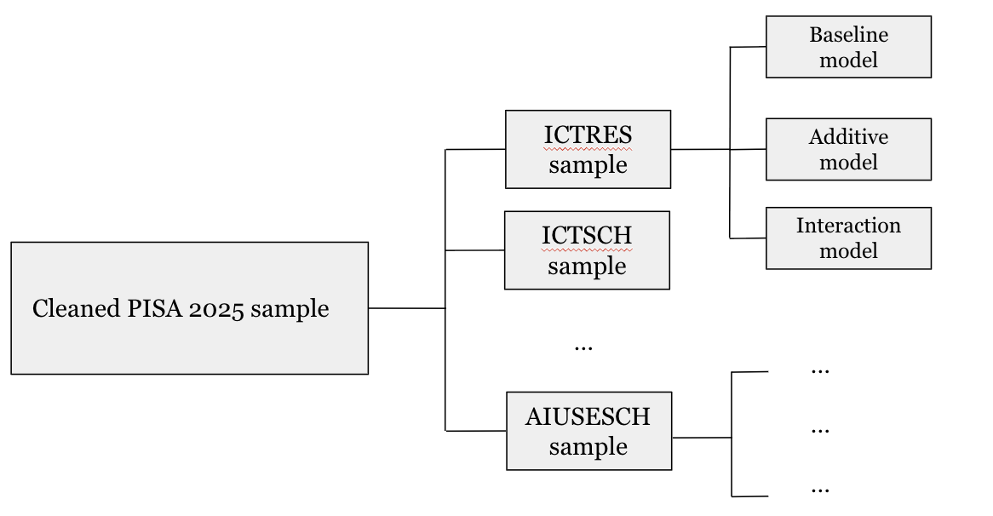

Results
Estimates for each ICT indicator are done independently. As mentioned in the methodology section, different samples are created to account for missing data, resulting in different sample sizes. Each sample excludes observations missing the selected ICT indicator. The baseline, additive, and interaction models are run for each sample to allow for same-sample comparison as shown in Table 2.

All models show a consistent, significant, and positive relationship between science scores and Economic, Social and Cultural Status (ESCS). The ESCS coefficients (baseline models) range from 30.22 to 32.32, and standardizing the beta values, they range from 0.294 to 0.330. For each unit increase in ESCS, the student’s science score is associated with an increase of approximately 30.22 to 32.32 science points, holding all other variables constant. Figure 2 shows the general positive trend using only one science score value of all observations in the sample. Only PV1SCIE (out of 10 total plausible outcomes) is used for illustration.
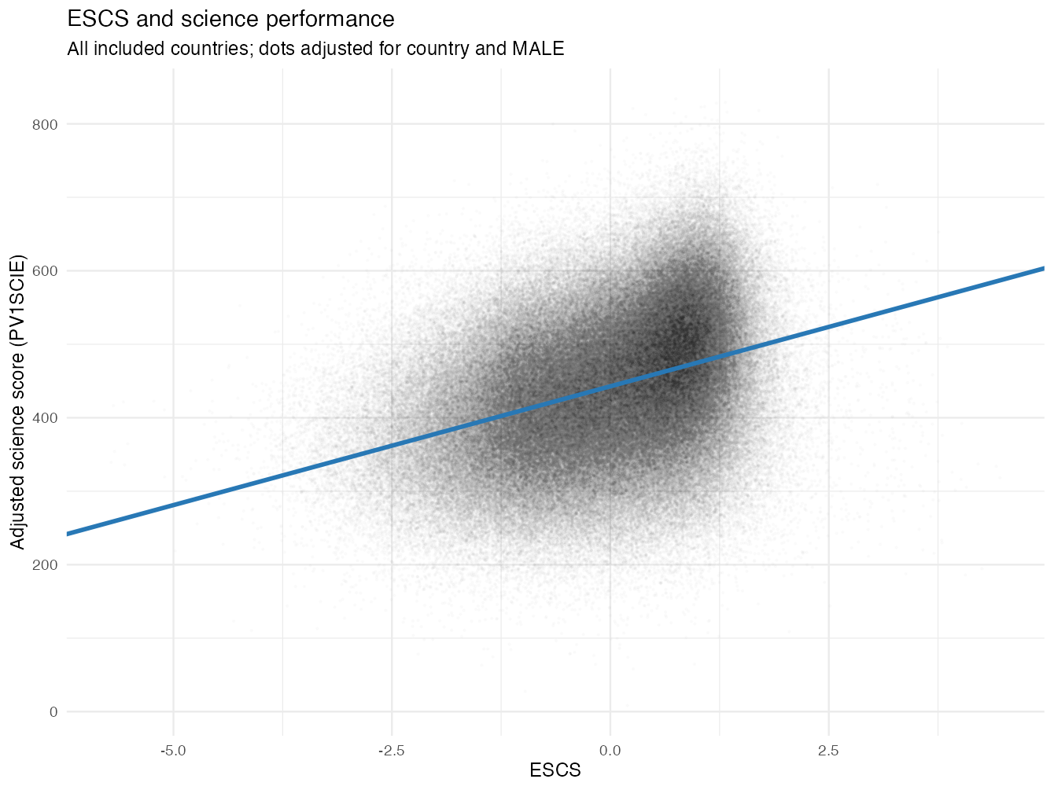
Figure 2. Trend adjusted for country and gender, including all samples

After controlling for ESCS, gender, and country, the additive models show varied associations between ICT indicators and science scores in Table 2. ICT access indicators show a significant yet small negative relationship, with the exception of ICT quality (ICTQUAL). ICT quality shows a positive association with science scores. ICT frequency on weekends and weekdays shows negative associations. ICT usage shows mixed associations. While the use of ICT for school activities outside of the classroom (ICTOUT) and students’ practices regarding online information (ICTINFO) show a small positive association with science scores, support or feedback via ICT shows a negative association. ICT interest indicators (INTICT and DIGINTLRN) have consistent positive associations with science scores, with the largest positive magnitude. Each unit increase in these ICT indicators is associated with a 13.26- and 14.04-point increase in science scores, respectively. AI usage shows a negative association with science scores.

The interaction term ESCS × ICT also shows mixed results with each ICT indicator. For access, all interaction terms were positive except for ICT resources (ICTRES), which shows no significant interaction. Figure 3 shows moderation plots for a few ICT indicators. From Figure 3.1, we can see that low ESCS students have a steeper slope, meaning more decreases in science scores for an increase in ICT availability. Figure 3.2 shows that high ESCS students are associated with more increase in science score from high quality of access to ICT than low ESCS students. The interaction terms of ICT frequency are both negative. In Figure 3.3, high ESCS students have a steeper slope, meaning more decreases in science scores for increase of ICT availability on weekends for high ESCS students. Although both indicators (Figure 3.1 and Figure 3.3) show an increase in the specific ICT indicator associated with a decrease in scores, they have opposite moderator relationships. Similar to the additive models, ICT indicators of use have varied interaction terms with no apparent pattern. ICTFEED has a negative interaction term, and ICTOUT and ICTINFO have no significant moderation. ICT indicators of ICT interest have no statistically significant moderation effects. Lastly, Figure 3.4 shows the moderation effect of students’ AI use at school. High SES students have a steeper slope, meaning more decreases in science scores associated with an increase in AI use.

It is important to note that after adding the ICT indicators and the interaction terms, the increase in R² is relatively small for some samples. For example, adding the interaction increases R² by 0.42% for ICTWKEND, 0.30% for ICTWKDY, and 0.09% for AIUSESCH. The practical explanatory power of interaction terms remains limited. The same-sample comparisons distinguish statistical significance from practical effect magnitude.

Overall, ICTSCH, ICTHOME, and ICTQUAL show positive interaction results. ICTWKEND, ICTWKDY, ICTFEED, and AIUSESCH show negative interaction results. ICTRES, ICTOUT, ICTINFO, INTICT, and DIGINTLRN show insignificant interaction results.

Table 2
Category | ICT Indicator | N | Model | ESCS | ICT variable | ESCS × ICT | R²
Access | ICTRES | 213,685 | Baseline | 30.22*** (1.49) | — | — | 0.4040
Access | ICTRES | 213,685 | Additive | 32.99*** (1.72) | -4.23*** (1.04) | — | 0.4049
Access | ICTRES | 213,685 | Interaction | 33.74*** (2.04) | -3.83*** (1.08) | 1.31 (0.79) | 0.4053
Access | ICTSCH | 296,746 | Baseline | 32.09*** (1.17) | — | — | 0.3252
Access | ICTSCH | 296,746 | Additive | 31.95*** (1.17) | -3.21*** (0.40) | — | 0.3267
Access | ICTSCH | 296,746 | Interaction | 31.85*** (1.17) | -2.52*** (0.46) | 1.94*** (0.36) | 0.3274
Access | ICTHOME | 287,984 | Baseline | 31.92*** (1.21) | — | — | 0.3194
Access | ICTHOME | 287,984 | Additive | 32.00*** (1.21) | -2.35*** (0.50) | — | 0.3200
Access | ICTHOME | 287,984 | Interaction | 31.32*** (1.18) | -1.83** (0.62) | 1.09* (0.46) | 0.3201
Access | ICTQUAL | 287,319 | Baseline | 32.04*** (1.21) | — | — | 0.3199
Access | ICTQUAL | 287,319 | Additive | 31.66*** (1.19) | 6.99*** (0.65) | — | 0.3241
Access | ICTQUAL | 287,319 | Interaction | 31.85*** (1.21) | 7.56*** (0.70) | 3.04*** (0.62) | 0.3251
Frequency | ICTWKEND | 277,166 | Baseline | 32.25*** (1.20) | — | — | 0.3184
Frequency | ICTWKEND | 277,166 | Additive | 32.54*** (1.19) | -13.99*** (0.81) | — | 0.3346
Frequency | ICTWKEND | 277,166 | Interaction | 31.60*** (1.13) | -16.61*** (0.98) | -5.95*** (0.61) | 0.3388
Frequency | ICTWKDY | 282,375 | Baseline | 32.23*** (1.21) | — | — | 0.3190
Frequency | ICTWKDY | 282,375 | Additive | 32.31*** (1.19) | -16.41*** (0.76) | — | 0.3455
Frequency | ICTWKDY | 282,375 | Interaction | 31.01*** (1.13) | -18.47*** (0.89) | -4.44*** (0.49) | 0.3485
Use | ICTFEED | 282,799 | Baseline | 32.23*** (1.24) | — | — | 0.3192
Use | ICTFEED | 282,799 | Additive | 32.84*** (1.24) | -9.76*** (0.84) | — | 0.3271
Use | ICTFEED | 282,799 | Interaction | 33.42*** (1.17) | -10.51*** (0.96) | -2.93*** (0.72) | 0.3281
Use | ICTOUT | 282,352 | Baseline | 32.32*** (1.21) | — | — | 0.3193
Use | ICTOUT | 282,352 | Additive | 31.48*** (1.09) | 5.25*** (0.94) | — | 0.3215
Use | ICTOUT | 282,352 | Interaction | 31.48*** (1.06) | 5.25*** (1.12) | 0.01 (0.98) | 0.3215
Use | ICTINFO | 275,677 | Baseline | 32.20*** (1.24) | — | — | 0.3198
Use | ICTINFO | 275,677 | Additive | 31.64*** (1.24) | 5.45*** (0.53) | — | 0.3226
Use | ICTINFO | 275,677 | Interaction | 31.76*** (1.23) | 5.28*** (0.58) | -0.78 (0.47) | 0.3227
Interest | INTICT | 276,693 | Baseline | 32.30*** (1.23) | — | — | 0.3221
Interest | INTICT | 276,693 | Additive | 31.16*** (1.20) | 13.26*** (0.64) | — | 0.3334
Interest | INTICT | 276,693 | Interaction | 31.08*** (1.22) | 13.04*** (0.73) | -0.66 (0.55) | 0.3334
Interest | DIGINTLRN | 276,810 | Baseline | 32.21*** (1.23) | — | — | 0.3205
Interest | DIGINTLRN | 276,810 | Additive | 31.02 ***(1.12) | 14.04*** (0.82) | — | 0.3350
Interest | DIGINTLRN | 276,810 | Interaction | 31.19*** (1.05) | 13.91*** (0.91) | -0.62 (0.60) | 0.3351
AI usage | AIUSESCH | 307,350 | Baseline | 31.95*** (1.16) | — | — | 0.3284
AI usage | AIUSESCH | 307,350 | Additive | 32.40*** (1.14) | -4.84*** (1.00) | — | 0.3301
AI usage | AIUSESCH | 307,350 | Interaction | 32.23*** (1.16) | −5.51*** (1.14) | −3.51*** (0.88) | 0.3310
* p < .05 All models' output is combined science scores (PV1-10SCIE), controlling for country (CNT) and gender (MALE)
** p < .01 Estimates incorporate students and replicate weights and all ten science plausible values. ESCS and ICT
*** p < .001 are constructed using PISA WLE. Coefficients are unstandardized; standard errors are shown in parentheses.

Figure 3
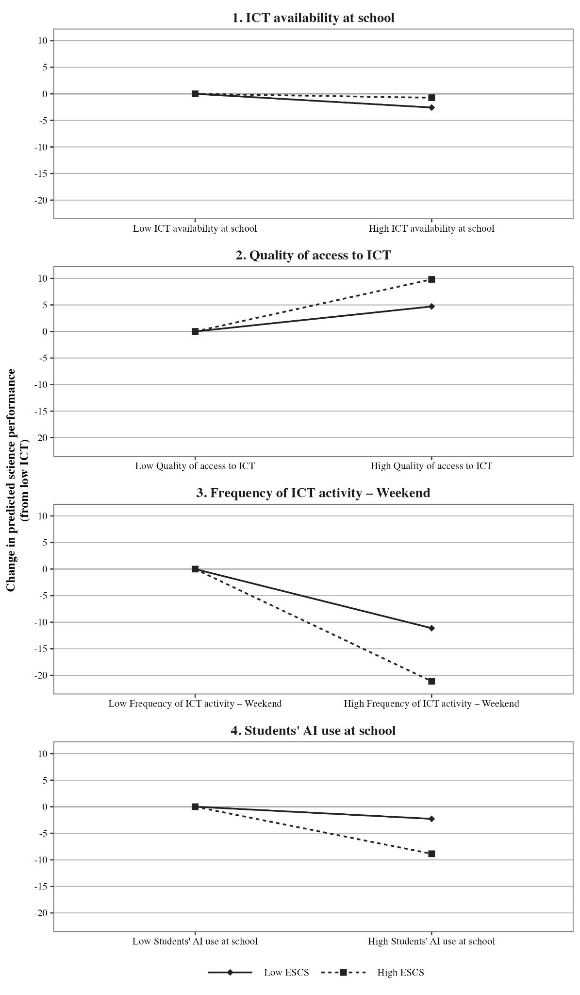
Low ICT and high ICT are defined by survey-weighted 25th and 75th percentiles
Both lines begin at zero to show changes in science scores relative to low ICT

Discussion
To explore the relationship between students’ SES and academic achievements, and how it changes with the use of ICT, we posed the following research questions:

RQ1. To what extent does students’ use of digital technologies moderate the association between socioeconomic status and academic achievement in PISA 2025?

RQ2. Can AI potentially mitigate academic achievement gaps across different socioeconomic groups?

To answer RQ1, each ICT indicator estimates a baseline, additive, and moderation model. The consistent positive relationship between SES and science achievement further confirms previous literature (Strenze, 2007; Scherer & Siddiq, 2019; Vargas-Montoya et al., 2023).

The additive models show that the relationship between ICT and science achievement differs across ICT indicators. Controlling for SES, there is a negative relationship between ICT access (with the exception of quality of access to ICT), ICT frequency, and AI usage and science achievement. Quality of access to ICT has a significant positive relationship with science achievement. This aligns with Vargas-Montoya et al.'s (2023) argument that the quality of access and ICT literacy may be more consequential than mere access. Frequency of ICT further confirmed that quality weighs more than frequency and access. There is no significant difference between ICTHOME and ICTSCH, while other studies cited a difference between frequency of use at home and at school. However, direct conclusions cannot be drawn because models are conducted on different samples due to the nature of this study.

ICT use shows mixed relationships. ICTFEED is the frequency of use for feedback sent by teachers, students, and educational software, as well as working on exercises on software (OECDa, 2026). It is negatively associated with academic achievement. ICTOUT is the use of ICT for school activities outside of the classroom. Its positive association could suggest that ICT is used productively for academic reasons, therefore aiding learning. ICTINFO is the students’ practices regarding online information. Previous literature consistently found a similar positive relationship between ICTINFO and academic achievement (Loh et al., 2023; Vargas-Montoya et al., 2023).

ICT interest consistently shows a positive association with science achievement, and a similar relationship is shown in other studies as well (Courtney et al., 2022; Ghimire & Regmi, 2025). ICT interest is often linked to students’ academic motivation. ICT interest could also be related to higher competency when using ICT; therefore, students use it more effectively in studies.

Moderation analysis also shows a varied direction of moderation. A key finding in the results is that all negative moderator terms are ICT indicators that are negatively associated with science scores. This means that these ICT indicators could potentially mitigate the gap between high and low SES students, but in a way that might be hurting instead of benefiting students. In other words, the increase of these ICT use is associated with a steeper decrease in scores of high SES students more than low SES students, narrowing the disparity. Loh et al. (2023) found a similar moderator analysis in the frequency of gaming in and out of the classroom. Excessive gaming decreases scores of high-SES students by 36.7 test points, while only decreasing 2.7 test points for low-SES students. They argue that this is because high-SES students have excess educational resources. When they are distracted by gaming or other non-productive use of ICT, they are giving up learning opportunities to gain much higher points than low-SES students would. The same could possibly be applied to the current result. More frequent use or access to ICT exposes high-SES students to higher potential academic losses from their abundant resources than low-SES students would.

Exceptions to this pattern are ICTHOME and ICTSCH. However, the effect size of the ICT variable on science scores is trivial, as displayed by a relatively flat slope in Figure 3.1. Another notable moderator is ICTQUAL. ICT quality and ESCS have a positive moderation, meaning that high quality of ICT potentially benefits high-SES students more than low-SES students. This potentially widens the gap between the academic achievements of low- and high-SES students. ICTQUAL contains a set of questions about sufficient digital resources at school, quality of internet at school, and digital support at school. A possible explanation could be that high-SES students get more support at school on using ICT effectively compared to low-SES students.

4 out of 5 ICT indicators that were positively associated with science scores did not show significant moderator terms.

Overall, to answer RQ1, ICT indicators show various associations with academic achievement as well as different interaction terms. It is important to analyze different aspects of ICT. 3 out of 4 access indicators show a positive interaction term, potentially widening the gap, but have varying directions of association with scores. Frequency indicators show that high-SES students are associated with larger score decreases than for low-SES students. This gives evidence that ICT can potentially narrow the achievement gap, but in a way that is hurting high-SES students more than low-SES students.

To answer RQ2, the new PISA ICT indicator AIUSESCH was analyzed. AIUSESCH combines the responses on how frequently students use AI chatbots (1) to summarise a text they had to read, (2) to conduct preliminary research on a topic, (3) to draft writing assignments, and (4) to help them learn. Overall, the analysis shows students’ frequent use of AI has a negative relationship with academic achievement. This aligns with the PISA report of a general downward trend in scores as frequency of AI increases (Frequency of AI use to help students learn is an exception) (OECD, 2026c).

The interaction term of ESCS and AI frequency is negative, meaning that it is a similar result as ICT frequency and ICT frequency of use for feedback, where AI might be hurting high SES students more than low SES students, therefore narrowing the achievement gap.

Limitations and Future Research
It is important to point out the limitations of this study and opportunities for future research. First, due to the nature of PISA assessments as an observational study, we can not establish causal relationships. Future studies can conduct experiments or use long-term data to conclude whether ICT indicators or socio-economic status cause any effects on students’ academic achievements.

Second, as part of the collection process, PISA only self-reports family background, which can result in inaccuracies. For example, scales with questions such as “how much do I agree or disagree with the following statements” or “how often do I use [blank] to help me learn” can be different for each student, resulting in over- or underestimation. Some studies use direct and performance-based assessments to empirically measure ICT literacy.

Third, this moderation study only controls for country and gender, and these do not account for all differences between students. Some other control variables other studies have used are whether students repeated a grade, age, immigration status, and first language. Kastorff et al. (2025), Vargas-Montoya et al. (2023), and Park & Weng (2020) explored impacts on performance of country-level factors such as income inequality, Gross Domestic Product per capita, and Digital Readiness Index. School-level factors such as digital resources, private/public schools, school size, and teacher training could be relevant controls as well. Future studies can also explore whether student motivation, prior achievement, and parental support have meaningful relationships with socioeconomic status and ICT use.

Fourth, some studies pointed out that there is a conceptual overlap between ESCS and the ICT indicators (Kastorff et al., 2025). According to OECD (2026), one of the components of ESCS is home possessions, which includes recording the number of devices at home, etc. ICT availability asks for the number of devices at home as well. This collinearity might result in a slight fluctuation in correlation.

Fifth, this study handles missing variables by drawing different samples for each ICT indicator. This means that we can not compare coefficients across different samples. Future studies can compile one cleaned sample and compare coefficients of ICT indicators directly.

Sixth, this study only has a general frequency of use of AI, ignoring many other aspects of AI use in education. Future studies can break down the specific uses of AI, such as using it to write essays, research, and quizzes, etc., to find meaningful differences among various uses. It can also extrapolate whether quantity over quality applies to AI as well. AI policy in different countries might affect the benefit students get from AI. For example, China and the United Arab Emirates have mandated education systems to implement AI education starting in 2025 (Sajadieh et al., 2026). Different AI implementations at schools can also have different effects on students. More studies should be done on how the guidance of AI use can benefit students. This study is only a starting point of research in AI in the education field.

Conclusion
This study explores whether ICT moderates the association between socioeconomic status and science achievement. Using the PISA 2025 cycle with 335,424 students across 44 countries, we analyze the relationship between socioeconomic status and science scores, with ICT in five categories (access, frequency, use, interest, and AI use) as moderators.

We confirmed the positive relationship between socioeconomic status and academic achievement, and found that ICT indicators correlate differently with achievement. Some ICT indicators show evidence of an increase in ICT associated with a larger decrease in achievement for high-socioeconomic status students than for low-socioeconomic status students. In other words, ICT could be narrowing the gap but yielding unfavorable achievement associations. We also found that expanding access cannot explain the association with academic achievement. According to previous literature, parallel guidance from parents and school play major roles in implementing ICT at schools. It places greater emphasis on weighing the quality of ICT over mere access to ICT.

This study also has limitations to consider. The PISA assessment is an observational study, which means causation cannot be concluded. AI is also introduced for the first time in the 2025 PISA cycle, but only with limited aspects. Future studies should look into the specific uses of AI and address its risks. AI will shape the future by exploring the interaction between technology and education.

References
American Psychological Association. (2026). Socioeconomic status. Socioeconomic status. Retrieved October 21, 2026, from https://www.apa.org/topics/socioeconomic-status
Bastani, H., Bastani, O., Sungu, A., Ge, H., Kabakcı, Ö., & Mariman, R. (2025). Generative AI without guardrails can harm learning: Evidence from high school mathematics. National Academy of Sciences, 122(26). https://doi.org/10.1073/pnas.2422633122
Brown, W. (2020). The Digital Divide. OSU Library. https://open.library.okstate.edu/learninginthedigitalage/chapter/the-digital-divide/
Bulut, O., & Cutumisu, M. (2018). When Technology Does Not Add Up: ICT Use Negatively Predicts Mathematics and Science Achievement for Finnish and Turkish Students in PISA 2012. Journal of Educational Multimedia and Hypermedia, 27(1), 25-42.
Campbell, J. (2023). Matthew effect. EBSCO. Retrieved October 21, 2026, from https://www.ebsco.com/research-starters/religion-and-philosophy/matthew-effect/
Chiao, C., & Chiu, C.-H. (2018). The Mediating Effect of ICT Usage on the Relationship Between Students’ Socioeconomic Status and Achievement. The Asia-Pacific Education Researcher, 27(2), 109-121. https://doi.org/10.1007/s40299-018-0370-9
Courtney, M., Karakus, M., Ersozlu, Z., & Nurumov, K. (2022). Large-scale Assessments in Education, 10. https://doi.org/10.1186/s40536-022-00128-6
Esen, E., & Adigüzel, O. C. (2023). The Effect of Socioeconomic Level on Academic Achievement: Evidence from PISA. Journal of Theoretical Educational Science, 16(4), 925–947. http://doi.org/10.30831/akukeg.1279154
Fayda-Kinik, F. S., & Cetin, M. (2024). ICT and academic achievement in secondary education: A hierarchical linear modelling. Journal of Computer Assisted Learning, 10. https://doi.org/10.1111/jcal.13070
Gabriel, S. (2024). Generative AI and Educational (In)Equity. International Conference on AI Research, 5(1), 133-142. https://doi.org/10.34190/icair.4.1.3153
Ghimire, N., & Regmi, S. (2025). ICT Access and Inequality in Global Reading Achievement: Cross-Level Interactions and Compensatory Effects in PISA 2018. Journal of Education and Training Studies, 13(3). https://doi.org/10.11114/jets.v13i3.7619
Gonz´ alez-Betancor, S. M., López-Puig, A. J., & Cardenal, M. E. (2021). Digital inequality at home. The school as compensatory agent. Computers & Education, 168, Article number: 104195. https://doi.org/10.1016/j.compedu.2021.104195
Guerra, J., Roblez, G., Vargas, V., Meneses, M., & Basantes-Andrade, A. (2026). Digital equity and socioeconomic gradients in PISA 2022 mathematics: an integrated equity-diagnostic framework for Latin America and the Caribbean. frontiers in Education, 11, Article number: 1810210. 10.3389/feduc.2026.1810210
Kastorff, T., Müller, M., & Greiff, S. (2025). Digital media use and availability can mitigate the digital divide: Meta-analytic insights from PISA 2022. Computers & Education, 238, Article 105409. https://doi.org/10.1016/j.compedu.2025.105409
Khan, S. (2024). Brave New Words: How AI Will Revolutionize Education (and Why That's a Good Thing). Penguin Publishing Group.
Loh, R. S. M., Kraaykamp, G., & van Hek, M. (2023). Student ICT resources and intergenerational transmission of educational inequality: testing implications of a reproduction and mobility perspective. European Sociological Review, 39(5), 804–819. https://doi.org/10.1093/esr/jcad008
Matjie, M. A., Nethavhani, A., & Matlakala, M. (2026). AI and the digital divide in education. Frontiers in Computer Science, 8, Article number: 1759027. 10.3389/fcomp.2026.1759027
Mimoudi, A. (2025). Generative AI to bridge the educational divide: Personalized learning and challenges. Social Sciences & Humanities Open, 12, Article number: 102140. https://doi.org/10.1016/j.ssaho.2025.102140
Organisation for Economic Co-operation and Development. (2009). PISA data analysis manual: SPSS (2nd ed.). https://doi.org/10.1787/9789264056275-en
Organisation for Economic Co-operation and Development. (2026a). ICT QUESTIONNAIRE PISA 2025 Main Survey. https://www.oecd.org/content/dam/oecd/en/data/datasets/pisa/pisa-2025-datasets/questionnaires/ICT%20QUESTIONNAIRE%20PISA%202025.pdf
Organisation for Economic Co-operation and Development. (2026b). PISA 2025 assessment and analytical framework. https://doi.org/10.1787/86c36975-en
Organisation for Economic Co-operation and Development. (2026c). PISA 2025 Results (Volume I). https://www.oecd.org/content/dam/oecd/en/publications/reports/2026/09/pisa-2025-results-volume-i_5265bfb1/73451bc5-en.pdf
Park, S., & Weng, W. (2020). The Relationship Between ICT-Related Factors and Student Academic Achievement and the Moderating Effect of Country Economic Indexes Across 39 Countries: Using Multilevel Structural Equation Modelling. Educational Technology & Society, 23(3), 1-15. https://www.jstor.org/stable/10.2307/26926422
Sajadieh, S., Fattorini, L., Perrault, R., Gil, Y., Parli, V., Santarlasci, L., Pava, J., Maslej, N., Altman, R., Brynjolfsson, E., Brodley, C., Clark, J., Dignum, V., Kumar, V., Landay, J., Lyons, T., Manyika, J., Niebles, J. C., Shoham, Y., . . . Weld, D. (2026). The AI Index 2026 annual report. Stanford Institute for Human-Centered Artificial Intelligence. https://hai.stanford.edu/assets/files/ai_index_report_2026.pdf
Scherer, R., & Siddiq, F. (2019). The relation between students’ socioeconomic status and ICT literacy: Findings from a meta-analysis. Computers & Education, 138, 13–32. https://doi.org/10.1016/j.compedu.2019.04.011
Spiezia, V. (2010). Does Computer Use Increase Educational Achievements? Student-level Evidence from PISA. OECD Journal: Economic Studies, 2010(1). http://dx.doi.org/10.1787/eco_studies-v2010-1-en
Strenze, T. (2007). Intelligence and socioeconomic success: A meta-analytic review of longitudinal research. Intelligence, 35, 401–426. https://doi.org/10.1016/j.intell.2006.09.004
Vargas-Montoya, L., Gimenez, G., & Fernández-Gutiérrez, M. (2023). ICT use for learning and students’ outcomes: Does the country’s development level matter? Socio-Economic Planning Sciences. https://doi.org/10.1016/j.seps.2023.101550

